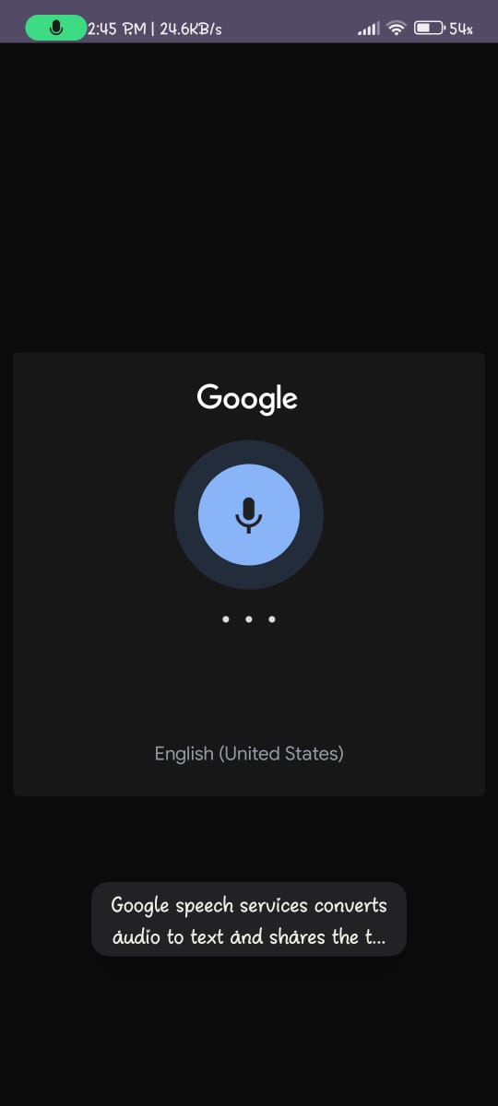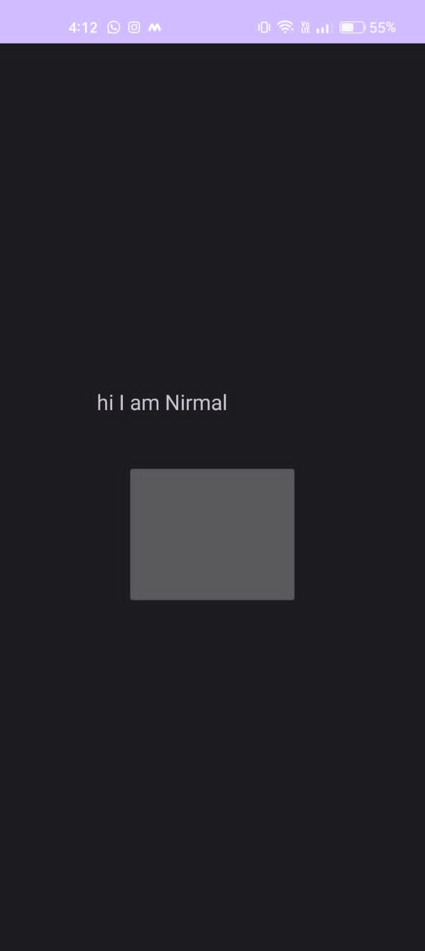

**activityMain.xml**

?xml version="1.0" encoding="utf-8"?>

<LinearLayout xmlns:android="http://schemas.android.com/apk/res/android"

xmlns:tools="http://schemas.android.com/tools"

android:layout_width="match_parent"

android:layout_height="match_parent"

android:gravity="center"

android:orientation="vertical"

tools:context=".MainActivity">

<TextView

android:id="@+id/tvText"

android:layout_width="wrap_content"

android:layout_height="wrap_content"

android:layout_marginBottom="10dp"

android:text=""

android:textSize="18sp" />

<ImageButton

android:id="@+id/btnSpeak"

android:layout_width="wrap_content"

android:layout_height="wrap_content"

android:background="@drawable/speak" />

</LinearLayout>

**AndroidManifest.xml**

<?xml version="1.0" encoding="UTF-8"?>

<manifest android:versionName="1.0" android:versionCode="1" package="com.example.speechtotext" xmlns:android="http://schemas.android.com/apk/res/android">

<uses-sdk android:targetSdkVersion="18" android:minSdkVersion="9"/>

<uses-permission android:name="android.permission.RECORD_AUDIO"/>

<uses-permission android:name="android.permission.INTERNET"/>

<application

android:theme="@style/AppTheme"

android:label="@string/app_name"

android:icon="@drawable/ic_launcher"

android:allowBackup="true">

<activity

android:name=".MainActivity"

android:label="@string/app_name">

<intent-filter>

<action android:name="android.intent.action.MAIN"/>

<category android:name="android.intent.category.LAUNCHER"/>

</intent-filter>

</activity>

</application>

</manifest>

**MainActivity.java**

import androidx.annotation.Nullable;

import androidx.appcompat.app.AppCompatActivity;

import android.content.ActivityNotFoundException;

import android.content.Intent;

import android.os.Bundle;

import android.speech.RecognizerIntent;

import android.view.View;

import android.widget.ImageButton;

import android.widget.TextView;

import android.widget.Toast;

import java.util.ArrayList;

public class MainActivity extends AppCompatActivity {

protected static final int RESULT_SPEECH = 1;

private ImageButton btnSpeak;

private TextView tvText;

@Override

protected void onCreate(Bundle savedInstanceState) {

super.onCreate(savedInstanceState);

setContentView(R.layout.activity_main);

tvText =(TextView) findViewById(R.id.tvText);

btnSpeak =(ImageButton) findViewById(R.id.btnSpeak);

btnSpeak.setOnClickListener(new View.OnClickListener() {

@Override

public void onClick(View view) {

Intent intent = new Intent(RecognizerIntent.ACTION_RECOGNIZE_SPEECH);

intent.putExtra(RecognizerIntent.EXTRA_LANGUAGE_MODEL,

RecognizerIntent.LANGUAGE_MODEL_FREE_FORM);

intent.putExtra(RecognizerIntent.EXTRA_LANGUAGE, "en-US");

try {

startActivityForResult(intent, RESULT_SPEECH);

tvText.setText("");

}

catch (ActivityNotFoundException e) {

Toast.makeText(getApplicationContext(), "Your device does not support Speech to Text",

Toast.LENGTH_SHORT).show();

e.printStackTrace();

}

}

});

}

@Override

protected void onActivityResult(int requestCode, int resultCode, @Nullable Intent data) {

super.onActivityResult(requestCode, resultCode, data);

switch (requestCode) {

case RESULT_SPEECH:

if(resultCode == RESULT_OK && data != null){

ArrayList<String>text = data.getStringArrayListExtra(RecognizerIntent.EXTRA_RESULTS);

tvText.setText(text.get(0));

}

break;

}

}

}